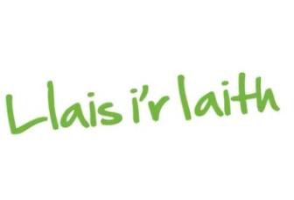

Cyfraniad Er Cof/A gift in Memory

Rwyf wedi gwneud taliad uniongyrchol* o £_____________ (noder swm y cyfraniad yma) tuag at waith Dyfodol i’r Iaith er Cof am (noder enw a chyfeiriad yr ymadawedig, os yn bosibl)
A direct payment* of £____ (amount) has been made towards the work of Dyfodol i’r Iaith in memory of (name and address of deceased if possible) ___________________________________________________________________
___________________________________________________________________

Manylion y rhoddwr/Donor Details:

Enw/Name ________________________________________________________
Cyfeiriad/Address ___________________________________________________
Cod Post/Postcode _______________________________________
Rhif ffôn cyswllt/Telephone contact details ____________________________

Diolch yn fawr i chi, mewn cyfnod anodd, am gyfrannu tuag at ein gwaith.
Thank you, in difficult circumstances, for contributing to our work.

*Manylion banc Dyfodol i’r Iaith Bank Details*:
Cod Dosbarthu/Sort Code: 30-98-85 Rhif Cyfri/Account No: 26699860
Enw’r Cyfrif/Account Name: Dyfodol i’r Iaith Cyf

Dychweler y ffurflen hon drwy ebost at meinir@dyfodol.net neu ei danfon yn y post at y cyfeiriad isod/Please send this form by email to meinir@dyfodol.net or by post to the address below:

