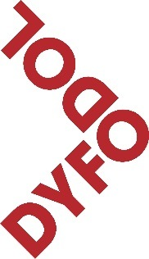
DYFODOL I’R IAITH
Hafan
2 Lôn Rhianfa
Ffynhonne
Abertawe
SA1 6DJ

heini@gruffudd.org
01792 455410

Y Prif Weinidog Carwyn Jones,
Llywodraeth Cymru
Bae Caerdydd
Caerdydd

Annwyl Brif Weinidog

STATEMENT ON THE WELSH LANGUAGE; November 12, 2013
We are pleased to see a statement on the Welsh language in your name.
However, we are concerned that the statement does not address the main challenge identified in the Big Conference, namely population movement, and the resulting action that is necessary in the economy, housing and planning , education and community development. We notice that many of the points in the declaration are not new announcements; many were passed or organized before the Big Conference, rather than being a result of the Conference.
These include the following:
• The Government’s intention to use more Welsh internally: this was mentioned in a paper that the Government Executive Board received a year ago, in October 2012. Is it possible to have a progress report on implementing the recommendations in that paper?
• TAN 20 had been underway before the Big Conference and it is clear that the TAN 20 was not strengthened as a result of the Big Conference. The intention to prepare a guide to support TAN 20 had already been noted in paragraph 3.3 of the document
• The statement about creating a Welsh app and other developments in the world of IT echo a statement made ​​by Leighton Andrews in May 2013, when he announced that £ 750,000 was available to spend in this area. Will the Government be developing the proposed website and app , or is it a response to a request for a grant under your IT plan?
We would also like to know whether you received the approval of the Partnership Council on the statement and when was a meeting held with the Council to discuss this statement.
While it is good to see the idea of '5 a day ' and efforts to produce a package for employers and employees, I wonder whether you could let us know how much funding will be provided and what plans are there to reach all Welsh workplaces with the message in bullet point 3 .
We look forward to your response to the above and would appreciate the opportunity to discuss the above with you with a view to seeing the new Government taking new and, hopefully, radical action in the key areas which are proportionate to the size the crisis being faced by the Welsh language.
Our concern at the moment is that there is little that is new in your statement today and it does not come close to responding to the main challenge outlined in the Big Conference.
Sincerely ,
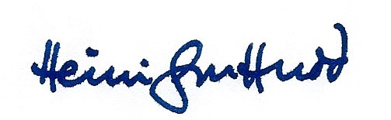

Heini Gruffudd
Cadeirydd
Dyfodol i’r Iaith

http://wales.gov.uk/about/civilservice/managementstructure/sdpb/boardp
http://wales.gov.uk/topics/planning/policy/tans/planning-and-the-welsh-language/?skip=1&lang=cy

